Projet - Les minis maisons
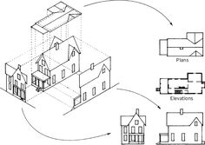

Activité 6:

Concevoir une projection orthogonale
Draw out the orthographic projection

Make sure to include the following in your orthographic projection:

• use graph paper
• include a minimum of 3 views (front, side and top views) and understand how each view relates to the other
• views are drawn correctly, all required lines are present (parallel or perpendicular), and all measurements are correct.
• dimensions for the drawing are present and the student provide a scale.
• the layout and appearance of the drawing is proportional. Views are spaced evenly.

Mme Kwiatkowski zlechien.weebly.com

